British Values at St.Ambrose
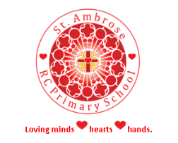
VALUE | What is it? | An example
The Rule of Law | To understand the importance of rules and laws and to abide by them. Realise that laws are they to protect us and keep us safe. | e.g. devise a set of rules for using the iPads in class.
Democracy | Everyone has a right to a voice and a vote but a majority will always win. | e.g. election of class monitors done by a vote.
Individual Liberty | Everyone has a right to an opinion and to be heard giving them freedom of speech. | e.g. children are encouraged in their right to free speech in the safe environment of school.
Mutual Respect | Everyone is respected and listened to. Everyone is equal and no one is more important than anyone else. | e.g. when someone else is speaking in a class discussion we ALL listen.
Tolerance of other beliefs and faiths | Whilst we promote Catholic values, we listen and learn about other beliefs and teach the children to respect them through celebrating differences. | e.g. Giving a Muslim child the opportunity to tell the class about their religious festivals etc.

SMSC at St.Ambrose
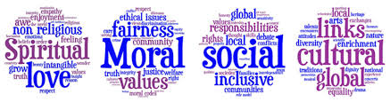

Value | What is it? | An example
Spiritual | Explore beliefs and experience; respect faiths, feelings and values; enjoy learning about each other, others and the surrounding world; use imagination and creativity; reflect. | e.g. investigate and discuss values of other faiths in RE or a history topic (we already do a lot of this in RE.)
Moral | Recognise right and wrong; respect the law; understand consequences; investigate moral and ethical issues; offer reasoned views. | e.g. discussion with children to understand every action has a consequence.
Social | Use a range of social skills; participate in the local community; appreciate diverse viewpoints; participate, volunteer and cooperate and resolve conflict. | e.g. making new friends, working with someone new. How would you first talk to them?
Cultural | Appreciate cultural influences; appreciate the role of Britain's parliamentary system; participate in culture opportunities; understand, accept, respect and celebrate diversity. | e.g. how places/countries have evolved and diversified. Celebrate different religious festivals.

