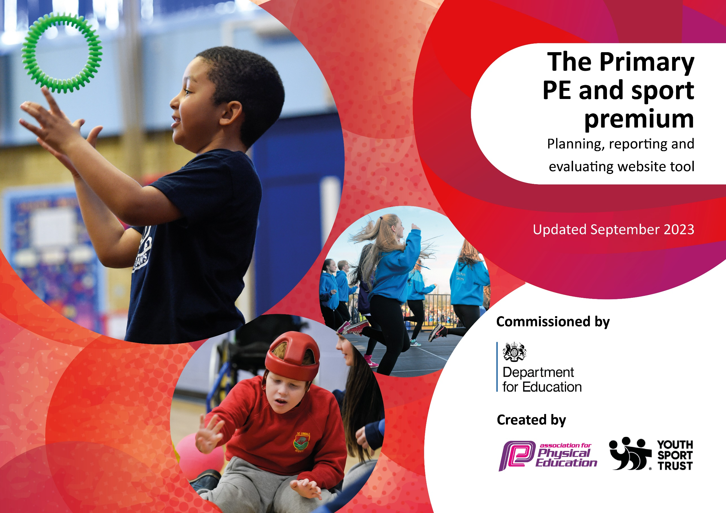

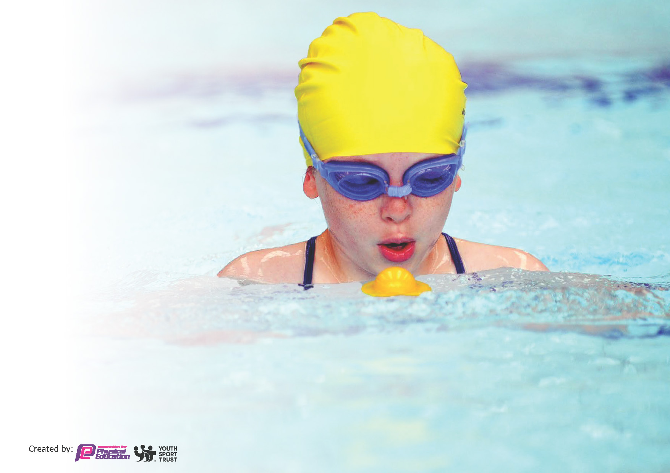
This template can be used for multiple purposes:
by:
- It enables schools to effectively plan their use of the Primary PE and sport premium
- It helps schools to meet the requirements (as set out in guidance) to publish information on their Primary PE and sport premium
- It will be an effective document to support Ofsted inspections enabling schools to evidence progress in Physical Education (PE) and evidence swimming attainment, which forms part of the PE National Curriculum. We would recommend schools consider
the Intent, Implementation and Impact of any spend, as examined within the Education Inspection Framework.

It is important that your grant is used effectively and based on school need.

Schools must use the funding to make additional and sustainable
improvements to the quality of the PE, School Sport and Physical Activity (PESSPA)
they offer. This means that you should use the Primary PE and sport premium to:

- Build capacity and capability within the school to ensure that improvements made now will benefit pupils joining the school in future years
- Develop or add to the PESSPA activities that your school already offers.

The Primary PE and sport premium should not be used to fund capital spend projects; the school’s core budget should fund these. Further detail on capital expenditure can be found in the updated Primary PE and sport premium guidance.

The Primary PE and sport premium guidance, outlines 5 key priorities that funding should be used towards. It is not

necessary that spending has to meet all the key priorities, you should select the priorities that you aim to use any funding towards.

Although completing this template is not a requirement for schools, schools are required to publish details of how they spend this funding. Schools must also outline what the impact this funding has had on pupils’ PE and sport participation and attainment and how any spending will be sustainable in the future. All funding must be spent by 31st July 2024.

The Department for Education has worked closely with the Association for Physical Education (afPE) and the Youth Sport Trust (YST) to develop this template and encourages schools to use it. This template is an effective way of meeting the reporting requirements of the Primary PE and sport premium.
Review of last year’s spend and key achievements (2022/2023)

We recommend you start by reflecting on the impact of current provision and reviewing your previous spend.

Activity/Action | Impact | Comments
Actions and activities have been reviewed and RAG rated on last year’s sports premium document (which can be found on the school website) and will feed into this year’s action plan.

Key priorities and Planning
This planning template will allow schools to accurately plan their spending.

Action – what are you planning to do | Who does this action impact? | Key indicator to meet | Impacts and how sustainability will be achieved? | Cost linked to the action
To continue the participation and engagement of children in sports and activities at lunchtimes and break times.  To continue to provide quality extra curriculum PE clubs after school (This includes a focus on girl’s football) | PE teacher and teaching staff, as they need to organize the activities for children to participate in.  PE teacher and teaching staff, as they need to organize the activities and clubs for children to participate in with a focus of enjoyment and feeding into school competitions. | Key indicator 2 -The engagement of all pupils in regular physical activity – the Chief Medical Officer guidelines recommend that all children and young people aged 5 to 18 engage in at least 60 minutes of physical activity per day, of which 30 minutes should be in school.  Key indicator 4: Broader experience of a range of sports and activities offered to all pupils.  Key indicator 2 -The engagement of all pupils in regular physical activity – the Chief Medical Officer guidelines recommend that all children and young people aged 5 to 18 engage in at least 60 minutes of physical activity per day, of which 30 minutes should be in school.  Key indicator 4: Broader experience of a range of sports and activities offered to all pupils. | More pupils meeting their daily physical activity goal, more pupils encouraged to take part in PE and Sport Activities.  More children are active and participate in extra curriculum clubs. Children demonstrate a positive pupil voice to the sports provision provided by the school. | Approximately £3200 costs per year for lunch and breaks cover from staff for specialist PE teacher to cover.  £300 for playground resources  Approximately £1700 in staffing costs for the time dedicated to running extra curriculum clubs.
Develop leadership skills within the school  Raise the Profile of PESS across the school by Celebrating success through newsletters, website & social media and inviting sportsmen and sportswomen into school to share their passion for sport and to motivate the children, including the delivery of sessions.  Raise the quality of teaching across the school  Maintain high quality of PE equipment to support high quality delivery of PESS | Children – Develop children as sports leaders so that they can lead an active break and lunchtime.  PE lead – needs knowledge to train the Sports leaders.  Children – Develop the engagement of children in regular activity.  Staff – Continue to develop PE teacher’s subject knowledge and impart this onto primary generalist teachers.  This includes employ a PE specialist to deliver the curriculum and staff to shadow and learn from.  Children – It will ensure high quality PE can be achieved.  Staff – Having quality equipment will aid providing the best delivery of PE | Key indicator 3 – The profile of PE and Sport is raised across the school as a tool for whole school improvement.  Key Indicator 4 – Broader experience of a range of sports.  Key Indicator 3 – The profile of PESS is raised across the school as a tool for whole school improvement.  Key Indicator 1 – Increased confidence, knowledge and skills of all staff in teaching and PE  Key Indicator 1 – Increased confidence, knowledge and skills of all staff in teaching and PE  Key indicator 2 -The engagement of all pupils in regular physical activity | Children engage in lunchtime activities and develop their own skills and knowledge as young leaders.  At least 90% of children enjoy PESS.  To have at least 2 visitors/coaches to come to school and motivate children in different sports.  Primary teachers more confident to deliver effective PE supporting pupils to undertake extra activities inside and outside of school, and as a result improved % of pupil’s attainment in PE.  Impact on the quality of the lessons being delivered and ensure higher quality learning. | PALS training package - £TBC  Fencing for Y6 - £600  Staff CPD – No additional cost  £9,987 – PE specialist allocated PE teaching time in an academic year.  Equipment resources allocation - £983

Further implement a bespoke assessment programme for PE  Continue to use PE Passport as a basis for the delivering the PE curriculum  To continually successfully participate in competitive school sports | PE teacher and class teachers.  PE teacher and class teachers.  PE teacher and staff – commitment of time to extra activities.  Children – Develop their skills and knowledge at a higher standard against other schools and competitions within school. | Key Indicator 1 – Increased confidence, knowledge and skills of all staff in teaching and PE  Key Indicator 1 – Increased confidence, knowledge and skills of all staff in teaching and PE  Key indicator 5 – Increased participation in sport. | The bespoke assessment system is used to accurately assess the attainment and progress of children,  High quality, consistent and mapped out curriculum delivered from EYFS to Y6  Continue to engage a high percentage of children in competitive sports.  Achieve Gold for the Games Mark award for a sixth year. | No additional cost  PE Passport - £850  Manchester School Sports competition subscription - £900

St. Ambrose RC Primary School (To be completed throughout the year)
Evidencing the impact of the PE and Sports Premium – Events and Competitions 2022/23
Events/Competitions | Month | Inter/Intra Competition | Number of participants |  |  | Number of leaders | Number of staff | Parents/  Volunteers | Event level  1/2/3 | Year Group(s) | AB Teams | Links with Clubs
 |  |  | Boys | Girls | Total
Cross Country | Sep 2022 | Inter | 16 | 12 | 28 | - | 3 | 3 | 1 | KS2 | A/B/C | KS2 Multisports
Cross Country | Sep 2022 | Inter | 16 | 12 | 28 | - | 3 | 3 | 1 | KS2 | A/B/C | KS2 Multisports

Key achievements 2023-2024
This template will be completed at the end of the academic year and will showcase the key achievements schools have made with their Primary PE and sport premium spending.

Activity/Action | Impact | Comments

Swimming Data
Meeting National Curriculum requirements for swimming and water safety.
Priority should always be given to ensuring that pupils can perform safe self-rescue even if they do not fully meet the first two requirements of the National Curriculum programme of study

Question | Stats: | Further context  Relative to local challenges
What percentage of your current Year 6 cohort can swim competently, confidently and proficiently over a distance of at least 25 metres? | % | Use this text box to give further context behind the percentage.  e.g., 30% - we are struggling to get pool space due to our local pool closing so we have had to use a much smaller local school pool. We have had to limit the number of pupils attending swimming lessons during one term which means some pupils have attended fewer swimming lessons than others.
What percentage of your current Year 6 cohort can use a range of strokes effectively [for example, front crawl, backstroke, and breaststroke]? | % | Use this text box to give further context behind the percentage.  e.g., Even though your pupils may swim in another year please report on their attainment on leaving primary school at the end of the summer term 2024

What percentage of your current Year 6 cohort are able to perform safe self-rescue in different water-based situations? | % | Use this text box to give further context behind the percentage.
If your schools swimming data is below national expectation, you can choose to use the Primary PE and sport premium to provide additional top-up sessions for those pupils that did not meet National Curriculum  requirements after the completion of core lessons. Have you done this? | Yes/No
Have you provided CPD to improve the knowledge and confidence of staff to be able to teach swimming and water safety? | Yes/No

Signed off by:

Head Teacher: | (Name)
Subject Leader or the individual responsible for the Primary PE and sport premium: | (Name and Job Title)
Governor: | (Name and Role)
Date:

