Calculations Policy for Multiplication and Division

To aid in the learning of multiplication and division children should:
- Multiply and divide numbers using concrete objects and pictorial representations.
- Be secure in all multiplication facts, as designated by year group, for progression.
- From Year 2, use inverse of multiplication and division to check accuracy of calculations.
- be supported in all methods, using a range of counting resources such as numicon, cubes, dienes, coins, counters, bead strings, number tracks, number lines, number squares, cuiseneres, dice etc.

 | Multiplication and Division  Mental/Recall | Strategies/Resources  (See Appendices for guidance) | Written | Representations | Problem Solving
Year 1 | Recall and use doubles of all whole numbers to 10 and corresponding halves.  Count in multiples of twos, fives and tens forwards and backwards.  Group AND share small quantities- understanding the difference between the two concepts.  Sharing  Grouping  Children should apply their counting skills to develop some understanding of grouping.  Use of arrays as a pictorial representation for division. 15 ÷ 3 = 5 There are 5 groups of 3.  15 ÷ 5 = 3 There are 3 groups of 5. | Doubling (x2)  Halving (÷2) | *Written methods are informal at this stage – see mental methods for expectation of calculations | 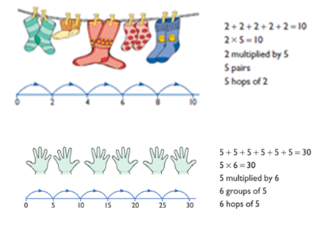  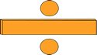  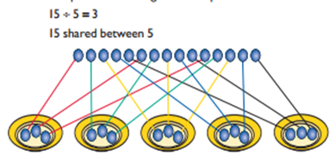  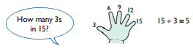 | Solve one-step problems involving multiplication and division, by calculating the answer using concrete objects, pictorial representations and arrays with the support of the teacher
Year 2 | Understand that multiplication is commutative but division is not.  Understand that multiplication is the inverse of division and vice-versa.  Count in steps of 2, 3 and 5 from 0 and when secure start from a different base number. Count in tens from any number, forwards and backwards.  Recall and use multiplication and division facts for the 2, 5 and 10 times tables, including recognising odd and even numbers.  Derive and use doubles of simple two-digit numbers  (numbers in which the ones total less than 10)  Calculate mathematical statements for multiplication (using repeated addition) and division with the multiplication tables and write them using the multiplication (x), division (÷) and equals signs (=). | Repeated Addition (e.g. 2+2+2+2)  Doubling (x2)  Halving (÷2)  Use doubles and halves and halving as the inverse of doubling.  Using known facts to find related facts | *Written methods are informal at this stage – see mental methods for expectation of calculations  Calculate mathematical statements for multiplication and division within the multiplication tables and write them using the multiplication (×), division (÷) and equals (=) signs. | Expressing multiplication as a number sentence using x  Using understanding of the inverse and practical resources to solve missing number problems.  7 x 2 = = 2 x 7  7 x = 14 14 = x 7  x 2 = 14 14 = 2 x  x ⃝ = 14 14 = x ⃝  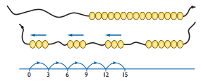 | Solve problems involving multiplication and division (including those with remainders), using materials, arrays, repeated addition, mental methods, and multiplication and division facts, including problems in contexts
Year 3 | Explain/reason that multiplication is commutative but division is not.  Count from 0 in multiples of 4, 8, 50 and 100 and when secure start from a different base number.  Recall and use multiplication and division facts for the 3, 4 and 8 times tables.  Derive and use doubles of all numbers to 100 and corresponding halves.  Derive and use doubles of all multiples of 50 to 500.  Write and calculate mathematical statements for multiplication and division using the multiplication tables that they know, including for two-digit numbers multiplied by one-digit numbers, using mental methods. | Doubling (x2)  Doubling again (x4)  Doubling again (x8)  Halving (÷2)  Halving again (÷4)  Halving again (÷8)  Partitioning e.g. to multiply by 7, multiply by 5 and by 2  Moving Digits to multiply/divide by 10  Using known facts to find related facts e.g. 20 x 3 = 60, so 60 ÷ 3 = 20 | Write and calculate mathematical statements for multiplication and division using the multiplication tables that they know, including for two-digit numbers times one-digit numbers, using informal methods and progressing to formal written methods. (appears also in Mental Methods) | Developing written methods using understanding of visual images  Develop onto the grid method  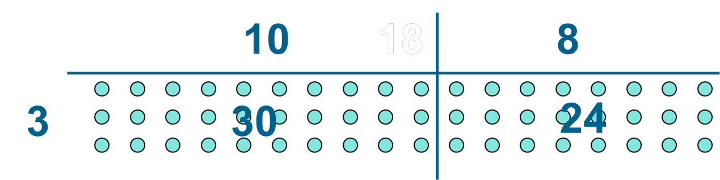  ÷ = signs and missing numbers  Continue using a range of equations as in year 2 but with appropriate numbers.  Grouping  How many 6’s are in 30?  30 ÷ 6 can be modelled as:  Becoming more efficient using a numberline  Children need to be able to partition the dividend in different ways.  48 ÷ 4 = 12  +40 + 8  10 groups 2 groups  Remainders  49 ÷ 4 = 12 r1  +40 + 8 + 1  10 groups 2 groups  Sharing – 49 shared between 4. How many left over?  Grouping – How many 4s make 49. How many are left over?  Place value counters can be used to support children apply their knowledge of grouping.  For example:  60 ÷ 10 = How many groups of 10 in 60?  600 ÷ 100 = How many groups of 100 in 600? | Solve problems, including missing number problems, involving multiplication and division (and interpreting remainders), including positive integer scaling problems and correspondence problems in which n objects are connected to m objects
Year 4 | Recall and use multiplication and division facts for multiplication tables up to 12 x 12.  Count in multiples of 6, 7, 9, 25 and 1000 from 0 and when secure start from a different base number.  Use knowledge of the 3 times table and doubling to derive and recall the 6 times table.  Use partitioning to double and halve any number, including decimals to one decimal place.  Use place value, known and derived facts to multiply and divide mentally, including: multiplying by 0 and 1; dividing by 1; multiplying together three numbers.  Recognise and use factor pairs and commutativity in mental calculations. | Doubling (x2)  Doubling again (x4)  Doubling again (x8)  Halving (÷2)  Halving again (÷4)  Halving again (÷8)  Doubling/halving can also be used for the relationships between 3, 6 and 12.  Partitioning e.g. to multiply by 13, multiply by 10 and by 3  To multiply by 9, multiply by 10 and subtract ‘1 lot’ of the multiple.  Moving Digits to multiply/divide by 10 and 100.  Using known facts to find related facts e.g. 200 x 3 = 600, so 600 ÷ 3 = 200 | Multiply two-digit and three-digit numbers by a one-digit number using informal methods and progressing to formal written layout.  Divide numbers up to 3 digits by a one-digit number using informal methods progressing to formal written method of short division and interpret remainders appropriately for the context. | 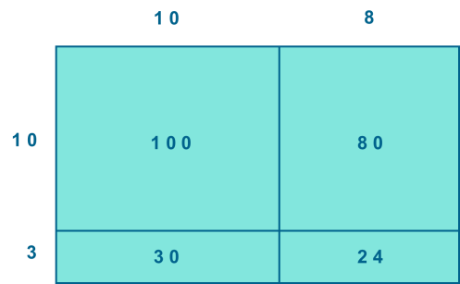  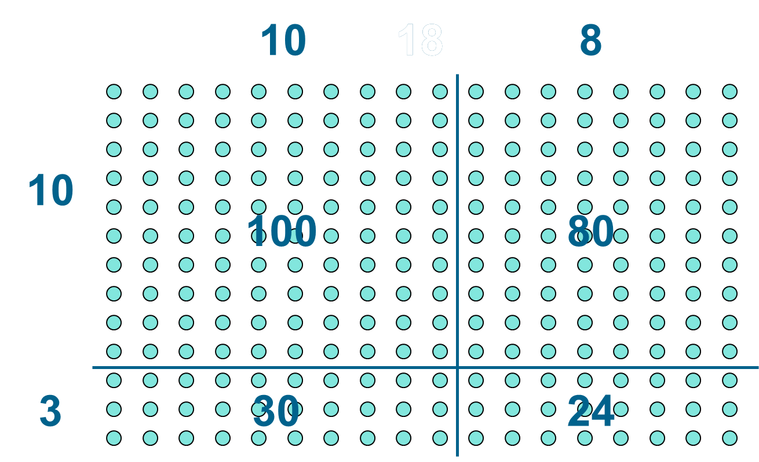 | Solve problems involving multiplying and adding, including using the distributive law to multiply two digit numbers by one digit, division (including interpreting remainders), integer scaling problems and harder correspondence problems such as n objects are connected to m objects
Year 5 | Identify multiples and factors, including finding all factor pairs of a number, and common factors of two numbers.  Count forwards or backwards in steps of powers of 10 (10, 100, 1000 etc.)  Multiply and divide whole numbers and those involving decimals by 10, 100 and 1000.  Recall prime numbers up to 19 and derive prime numbers up to 100.  Recall square numbers up to 144 and derive cube numbers.  Apply understanding that a remainder is a fraction of a whole.  Use partitioning to double or halve any number, including decimals to two decimal places. | Doubling (x2)  Doubling again (x4)  Doubling again (x8)  Halving (÷2)  Halving again (÷4)  Halving again (÷8)  Doubling/halving can also be used for the relationships between 3, 6 and 12.  Partitioning e.g. to multiply by 24, multiply by 20 and by 4.  To multiply by 99, multiply by 100 and subtract ‘1 lot’ of the multiple.  Moving Digits to multiply/divide by 10, 100 and 1000.  Use multiplication/division facts to find equivalent decimal and decimal fraction remainders. e.g. 98 ÷ 4 = 24r2 = 24r2/4 = 24 ½ = 24.5  Using known facts to find related facts | Multiply numbers up to 4 digits by a one- or two-digit number using a formal written method, including long multiplication for two-digit numbers.  Divide numbers up to 4 digits by a one-digit number using a formal written method of short division and interpret remainders appropriately for the context. | 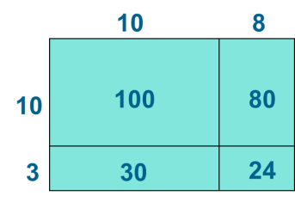  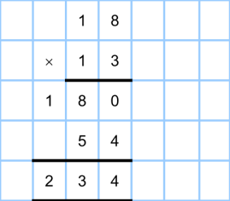  Same method as Y4 | Solve problems involving addition, subtraction, multiplication and division and a combination of these, including understanding the meaning of the equals sign  Solve problems involving multiplication and division, including scaling by simple fractions and problems involving simple rates
Year 6 | Associate a fraction with division and calculate decimal fraction equivalents. (e.g. 0.375 for a simple fraction – 3/8)  Identify common factors, common multiples and prime numbers.  Use partitioning to double or halve any number, including decimals to two places. | Doubling (x2)  Doubling again (x4)  Doubling again (x8)  Halving (÷2)  Halving again (÷4)  Halving again (÷8)  Doubling/halving can also be used for the relationships between 3, 6 and 12.  Partitioning e.g. to multiply by 3.5, multiply by 3 and by 0.5.  To multiply by 1.9, multiply by 2 and subtract ‘0.1 lot’ of the multiple.  Moving Digits to multiply/divide by 10, 100 and 1000.  Use multiplication/division facts to find equivalent decimal and decimal fraction remainders. e.g. 24 3/8 = 0.375  (1/4 = 0.25, 1/8 = 0.125 so 3/8 = 0.125 x 3 = 0.375)  Using known facts to find related facts | Multiply multi-digit numbers up to 4 digits by a two-digit whole number using a formal written method of long multiplication.  Divide numbers up to 4 digits by a two-digit number using a formal written method of short division where appropriate, interpreting remainders according to the context.  Use written division methods in cases where the answer has up to two decimal places. | 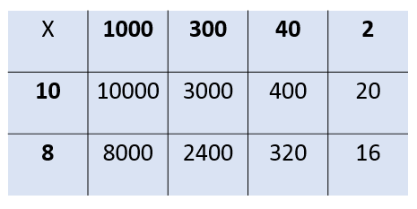  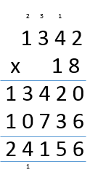  Formal written methods – long and short division  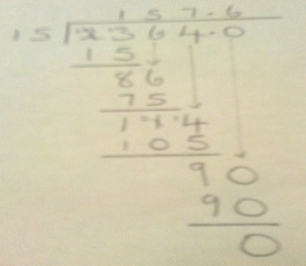 | Solve problems involving addition, subtraction, multiplication and division

