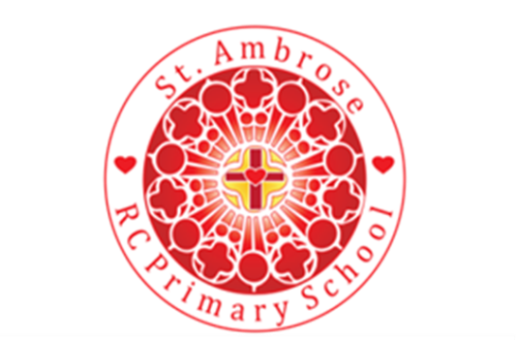
Overview of Religious Education at St Ambrose 2023 - 2024
Our rich curriculum embraces our Catholicity at its heart and complies with the Religious Education Directory requirements.
Children currently follow the 'Come and see" scheme alongside the 'Caritas in Action' programme which looks at the social teachings of the church. We have had the highest quality CPD and are currently producing a best practice model of planning and delivery. The Catholic Cluster of schools contributes to the cost of this developmental work.
Each class produces a class RE book which showcases this outstanding practice and outcomes over time.
All classes also have planned acts of collective worship on a daily basis. As the children progress through the school they take pleasure in planning these for themselves. We use a child friendly version of Lectio Divina for the study and use of Sacred Scripture.
We plan our work in 3 areas: The Catholic Life of the school (Witness, Welfare and Welcome), Word and Worship. You can see below a brief overview of each area. A ‘living SEF’ which is a collation of outstanding evidence from each class is available to enjoy.
Area | What this means | An example
Word of God | Listening to and being part of the story of Jesus Christ as the centre of everything in our school and challenging ourselves by the power of his word. | Children learn about stories and passages from the Bible. We promote Gospel values and their relevance to everyday life and living. God’s word is central to our faith and the lives we are called to lead as followers of Christ. Scripture is used as a starting point for whole school and class led prayer and worship and Gods word is often the focus of prayer and thought. Prayer and worship session always include Scripture. Lectio Divina helps us hear the Divine Word of God. It’s when the magic happens…Our Gift garden is a place for meditative contemplation as well as worship and words form Scripture inspire the pupils to think deeply.
Welcome | How we put Jesus at the centre of our community and reach out and celebrate the diverse needs of our community. | We feel the presence of Christ’s love in the warmth of our welcome as we open our doors, our hearts and our minds to serve, strengthen and encourage all. Our child Welcome committee does a wonderful job. All who visit or work with our school and Parish community are treated with dignity and we reach out with ‘open hands’ as we live our Mission daily. This can be witnessed in the joy around the school and the respect adults and children show to each other. We have ‘Loving Hearts, Minds, Hands.’
Welfare | How we cultivate an attitude of love, care and respect for each other in our community. | Our Inclusion practice is evidence that the explicitly Christ centred ethos is loving, creative, compassionate, highly positive and fosters a high level of understanding, empathy, forgiveness and respect for all. There have been no permanent exclusions at the school over the past 4 years and only a few children have been instructed to take short fixed term exclusions – these exclusions were decided upon in order to plan suitable programmes of support for the child and family. Parents have been fully supportive and included in decision making. The outcomes of this have been highly successful resulting in the children achieving well academically, socially and emotionally.
Worship | Opportunities that we provide to use the Scriptures to celebrate together so we can demonstrate the glory of God in our lives. | Our GIFT Chaplaincy team take a lead in preparing pupil prayer groups which enables pupils to be actively prayerful during the significant dates of the liturgical calendar. We are actively engaged with the Parish in the Sacramental programme and work closely with them to ensure the triangle of home school and Parish support children in their sacramental journey. We have our Monday Gospel assemblies to which families are invited and a range of celebrations through the year which involve both parish and family in worshipping together. We work with the Parish closely to support our many children with additional needs so that they can access the sacramental programme in a way that is enabling and meaningful for them and their family.
Witness | Witnessing the key values of Jesus such as in our Mission statement ‘In God’s family, we grow and learn in love, hope and faith,’ We acknowledge that he is with us in every aspect of school life. | Gospel values are understood and evidenced in policies and procedures of the school. Scripture is read during collective worship and child led worship. This impacts significantly on learning and the life of the school. The behaviour of pupils is good and often outstanding. In lessons and around school pupils are courteous and considerate. Children at St Ambrose tell us they value the adults who work with them in school and come to school wanting to learn. They feel safe because they know that adults will keep them safe in school. Pupils know about different forms of bullying and are aware of a range of prejudices. They agree that bullying is rare since new behaviour-management systems and lunch time activities were introduced in conjunction with their views. The St Ambrose strap line – ‘Loving Minds, Hearts, Hands,’ has developed over the last year has permeated all aspects of school work and made a significant impact on pupils learning and development.

